**TRIBHUVAN UNIVERSITY**

**INSTITUTE OF ENGINEERING**

**PURWANCHAL CAMPUS**

**A Minor Project Final Report**

**On**

**Radio Frequency Based Metal Detecting Robotic Vehicle**

**Submitted By:**

Saphal Bhattarai (PUR076BEI032)

Shishir Parajuli (PUR076BEI035)

Sulab Nepal (PUR076BEI042)

Pushpa Kamal Dahal (PUR076BEI026)

Department of Electronics and Computer Engineering

Purwanchal Campus

Dharan, Nepal  
  
In partial fulfillment for the award of the Bachelor’s Degree in Electronics, Communication and Information Engineering  
  
June 2023

# DECLARATION

We hereby declare that the report of the project entitled “**Radio Frequency Based Metal Detecting Robotic Vehicle**” which is being submitted to the **Department of Electronics and Computer Engineering, IOE, Purwanchal Campus**, in the partial fulfillment of the requirements for the award of the Degree of Bachelor of Engineering in **Electronics, Communication and Information Engineering**, is a bonafide report of the work carried out by us. The materials in this report have not been submitted to any university or institution for the award of any degree, and we are the sole authors of this entire work, with no additional sources than those stated below.

Saphal Bhattarai [PUR076BEI032] ________________________

Shishir Parajuli [PUR076BEI035] ________________________

Sulab Nepal [PUR076BEI042] ________________________

Pushpa Kamal Dahal [PUR076BEI026] ________________________

**Date:** June 2023

**©** **COPYRIGHT**

The author has agreed that the library, Department of Electronics and Computer Engineering, Purwanchal Campus, may make this report freely available for inspection. Moreover, the author has agreed that the permission for extensive copying of this project work for scholarly purpose may be granted by the professor/lecturer, who supervised the project work recorded herein or, in their absence, by the head of the department. It is understood that the recognition will be given to the author of this report and to the Department of Electronics and Computer Engineering, IOE, PurwanchalCampus in any use of the material of this report. Copying of publication or other use of this report for financial gain without approval of the Department of Electronics and Computer Engineering, IOE, Purwanchal Campus and author’s written permission is prohibited.

Request for permission to copy or to make any use of the material in this project in whole or part should be addressed to department of Electronics and Computer Engineering, IOE, Purwanchal Campus.

# ACKNOWLEDGEMENT

We would like to express our sincere gratitude towards the Institute of Engineering, Tribhuvan University for the inclusion of minor project during Bachelor’s in Electronics and Communication Engineering. We are also thankful to our supervisor **Er. Manoj Kumar Guragain** and the Department of Electronics and Computer Engineering, IOE, Purwanchal Campus for rendering us with the resources and support which is required for this project.

Saphal Bhattarai [PUR076BEI032]

Shishir Parajuli [PUR076BEI035]

Sulab Nepal [PUR076BEI042]

Pushpa Kamal Dahal [PUR076BEI026]

# ABSTRACT

The project is delineated to make a robotic vehicle with a metal detecting system embedded in it. The design and implementation of a robotic vehicle with metal detection has been provided in this study, which includes hardware, software, and communication settings. 8051 platforms and RF technology have been used for the implementation of the system. In this project, robotic vehicle design and application with using 8051 programming on a platform has been presented. This robotic device has been developed with the communication of transmitter and receiver circuit. 8051 microcontroller has been used as the robot's brain. The robot has hardware components such as bluetooth module, arduino,motor driver and buzzers. The desired direction can be selected by the user of the robotic vehicle using transmitter circuit to control the movement of the vehicle. Thus, the robot can detect metallic objects and metallic obstacles.

***Keywords****: Metal detector, Micro controller, Radio frequency, Robotic Vehicle*

Table of Contents

DECLARATION i

COPYRIGHT ii

ACKNOWLEDGEMENT iii

ABSTRACT iv

List of Figures 7

List of Tables 7

List of Abbreviations 8

1. INTRODUCTION 9

1.1 Background 9

1.2 Motivation 9

1.3 Project Objectives 10

1.4 Project Scope and Applications 11

2. LITERATURE REVIEW 4

3. REQUIREMENT ANALYSIS 7

3.1 Hardware Requirements 7

3.1.1 Arduino Uno 7

3.1.2 DC Motor 8

3.1.3 Buzzer 9

3.1.4 Bluetooth Module 10

3.1.5 Coils 10

3.1.6 Motor Driver IC (L293D) 11

3.2 Software Requirements 11

3.2.1 Keil µVision 11

3.2.2 MiniPro 12

3.2.3 Arduino IDE 13

3.2.4 Proteus 13

4. SYSTEM ARCHITECTURE AND METHODOLOGY 15

4.1 Block Diagram/ Architecture 15

4.1.1 Metal Detecting Part 15

4.1.2 Transmitter Part 16

4.1.3 Receiver Part 16

4.2 Description of Working Principle 17

4.2.1 Metal Detection Working: 17

4.2.2 Robotic Vehicle Working 18

4.3 Flowcharts/Algorithms 20

5. IMPLEMENTATION DETAILS 21

5.1 Hardware Implementation 21

5.1.1 Arduino Uno for Metal Detection 21

5.1.2 DC Motor Interfacing with 8051 Microcontroller 22

5.1.3 RF Remote Control 25

6. RESULTS AND ANALYSIS 28

6.1 Metal Detection System 28

6.2 Robotic Vehicle 29

7. FUTURE ENHANCEMENT 30

8. CONCLUSION 31

9. APPENDICES 32

Appendix A: Project Budget 32

Appendix B: Project Schedule 33

Appendix C: Circuit Diagram 34

References 37

List of Figures

Figure 3-1: Arduino UNO 7

Figure 3-2: DC Motor 8

Figure 3-3: Buzzer 9

Figure 3-4: Bluetooth Module 10

Figure 3-5: Copper Coils 10

Figure 3-6: L293D Motor Driver IC 11

Figure 3-7: Keil µVision 12

Figure 3-8: MiniPro 12

Figure 3-9: Arduino IDE 13

Figure 3-10: Proteus 14

Figure 4-1: Block Diagram of Metal Detector 15

Figure 4-2: Block Diagram of Transmitter Unit 16

Figure 4-3: Block Diagram of Receiver Unit 16

Figure 4-4: Flowchart of the System 20

Figure 5-1: Metal detector using Arduino schematic 21

Figure 5-2: DC Motor Interfacing with 8051 Microcontroller 23

Figure 5-3: Making of the Transmitter Unit 26

Figure 5-4: Making of the receiver unit 27

Figure 6-1: Metal Detection System 28

Figure 6-2: Robotic Vehicle 29

Figure 9-1: Metal Detection Circuit 34

Figure 9-2: Transmitter Circuit 34

# List of Tables

Table 9-1: Project Budget 32

Table 9-2: Project Schedule 33

# List of Abbreviations

AC Alternating Current

BFO Beat Frequency Oscillation

CPU Central Processing Unit

DC Direct Current

GND Ground

GPR Ground Penetrating Radar

IC Integrated Circuit

IDE Integrated Development Environment

IT Information Technology

KB Kilo Byte

MCU Micro Controller Unit

MHz Mega Hertz

PCB Printed Circuit Board

RAM Random Access Memory

RF Radio Frequency

ROM Read Only Memory

VLF Very Low Frequency

# INTRODUCTION

## Background

A metal detector detects the presence of metal in the immediate vicinity. Metal detectors can be used to locate metal inclusions within things or metal objects on the ground. For metal detection, this research employs a robotic vehicle. The vehicle is equipped with a metal detection technology that detects metals beneath the vehicle and informs the driver via a buzzing sound. As a result, when a metal detection system is combined with a robotic vehicle, the robotic vehicle can be controlled using RF technology.

The project depicts real-life robotic vehicles that are capable of detecting land mines and other metal-based things in their path. This action is carried out by the system in conjunction with an 8051 series microcontroller. The push buttons are used to direct the vehicle to move forward, backward, left, or right. The vehicle is guided by two motors at the receiving end in accordance with the commands received. When a command is issued, it is communicated via an RF transmitter.

## Motivation

There may be foreign metals presence in the concrete, sands, wires, and pipes that needs to be removed in many circumstances. Metal items, such as nails, can harm cutting instruments in the forestry industry. Similarly, manually searching caves or tunnels for metals can be a dangerous profession. In any difficult setting, robots can be utilized as a substitute for human labor.

## Problem Definition

The fundamental issue occurs in the areas of cost, portability (reduction in bulkiness), ease of usage, and so on. The device must also be both cost-effective and a fully functional robotic vehicle. The challenge is to create a device that can identify any metal in the vicinity. As a result, these are the existing issues that the project will address.

## Project Objectives

The main objectives of our project are listed below:

* To design, simulate and construct metal detecting system
* To make robotic vehicle based on RF technology.

**1.5** **Project Scope and Applications**

1. **Landmine Detection**

Land mines have been detected using metal detectors. A simple loop metal detector is one of the oldest methods for detecting land mines. Trained soldiers would sweep across a suspected minefield and probe for any evidence of buried metal with long prods.

**2. Archaeology**

Metal is found in many historic remains from the post-Paleolithic period. Pots, containers, weapons such as spears and swords, and tools such as hammers and chisels, .

**3. Security Screening**

There are metal detectors that can be used for locating metallic items on a person. Furthermore, similar systems can be employed in airports to identify guns, arms, and ammunition

4. I**ndustrial metal detectors**

During manufacturing process, metal shards can be resulted from broken processing machinery that can contaminate food, which is a serious safety concern in the food industry.

# LITERATURE REVIEW

In this area, previous research has been analyzed, and some of the methods and working principles used have been summarized.

VLF, also known as Induction Balance, could detect both ferrous and non-ferrous metals. There will be two balanced coils: the outer coil will operate as a transmitter, transmitting the magnetic field to the item using alternating current (AC), and the inner coil will act as a receiver, picking up and amplifying the magnetic field created by the object Despite its outstanding performance in distinguishing ferrous and non-ferrous items, VLF has problems coping with mineralized settings [1].

BFO is a basic and simple metal detector that uses two radio frequency (RF) oscillators that are adjusted to be almost identical to each other. However, it lacks sufficient precision and control. [2].

The search coil's changing magnetic field creates eddy currents in metal elements, and the eddy currents' counter-magnetic field may be detected. The integrator's output is a DC voltage that rises or falls when metal is detected, making it simple to add an indicator. The integrator voltage can be used to drive a VCO circuit if you prefer a BFO-like pitch response. The voltage can be used to regulate the amplitude of a fixed tone for a loudness response. [3]

**REQUIREMENT ANALYSIS**

Our project merges both hardware and software tools. The hardware components and software used in this project are briefly explained below.

## **Hardware Requirements**

### Arduino Uno

Arduino UNO is an open-source programmable microcontroller board that can be used in a variety of electronic applications. This Arduino board has an output that can control relays, LEDs, servos, and motors, and it may be used with other Arduino boards, Arduino shields, and Raspberry Pi boards. The Arduino UNO has an Atmega328 AVR microprocessor, six analogue input pins, and 14 digital I/O pins, six of which are utilized as PWM outputsA close-up of a computer chip

Figure 3.1: Arduino UNO

### DC Motor

A DC motor is a type of electric motor that transforms direct current electrical energy into mechanical energy. Armature, field coil or stator, commutator, and brushes make up the system. It has the ability to precisely control the pace of its components, which is essential for industrial machines. DC motors can start, A close-up of a binoculars
stop, and reverse quickly.

Figure 3.2 : DC Motor

### Buzzer

A buzzer is an electrical device that emits a buzzing sound and is used for signaling in our everyday life. Piezoelectric buzzers, electromechanical buzzers, and mechanical buzzers are the three types. These can be found in everyday items such as air conditioners, ovens, washing machines, thermometers, clocks, and a variety A picture containing appliance, kitchen appliance
device.

Figure 3.3:Buzzer

### Bluetooth Module

The HC-06 bluetooth module is a slave bluetooth module designed for wireless serial communication. It is a slave module meaning that it can receive serial data when serial data is sent out from a master bluetooth device(device able to send serial data through the air: smart phones, PC).When the module receives wireless data, it is sent out through the serial interface exactly at it is received.

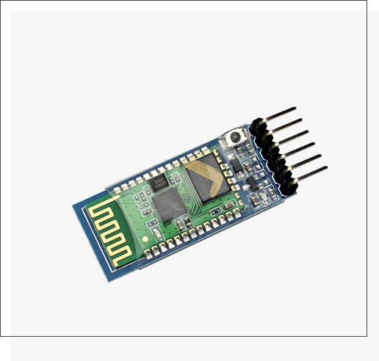

Figure 3.4 : Bluetooth module

### Coils

The term "coil" refers to a length of rope or wire that has been twisted into a series of loops (spiral of wire). It's a current-carrying wire spiral with one or more turns, usually roughly round or cylindrical, designed to produce a magnetic field or give electrical resistance or inductance.

Figure 3-5: Copper Coils

### Motor Driver IC (L293D)

The L293D is a dual H-bridge motor driver integrated circuit (IC) that allows bidirectional load control. Because they take a low-current control signal and convert it to a higher-current signal, motor drivers operate as current amplifiers. The motors are driven by this increased current signal. Two H-bridge driver circuits are included into the L293D. Two DC motors can be driven in both forward and reverse directions simultaneously in the common mode of operation. The linked driver is enabled when the enable input is high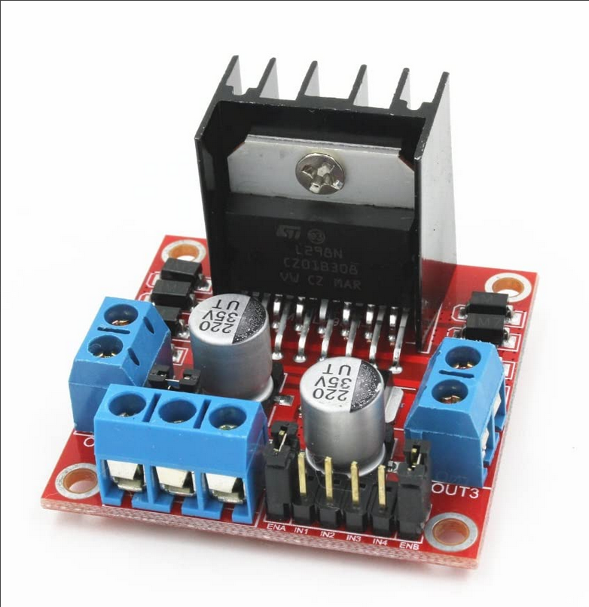.

Figure 3-6: L293D Motor Driver IC

## **Software Requirements**

### **Keil** **µVision**

In a single robust environment, the Keil Vision IDE combines project management, run-time environment, build capabilities, source code editing, and program debugging. Vision is simple to use and speeds up the development of embedded software. Multiple screens are supported by Vision, and you can design unique window layouts anywhere on the visual surface.

It serves as a compiler for our embedded C software, which produces a hex file that is sent to the microcontroller through the minipro programmer.

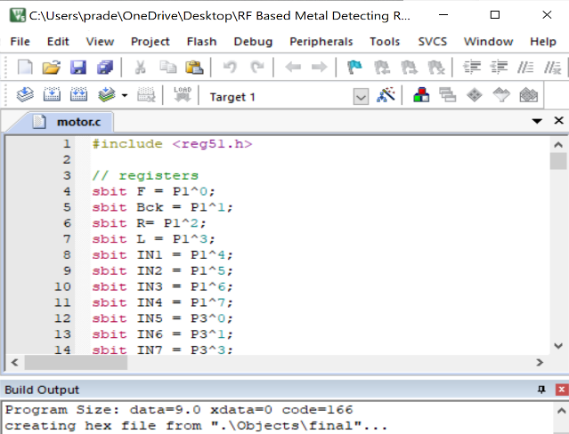

Figure 3.2.1: Keil µVision

### MiniPro

MiniPro is a universal programmer that can program a variety of microcontroller integrated circuits. For our project, we used it to program 8051 microcontrollers. With high-density SMD technology, this programmer is well-designed. It features a unified user interface that is easy to navigate and fully functioning.

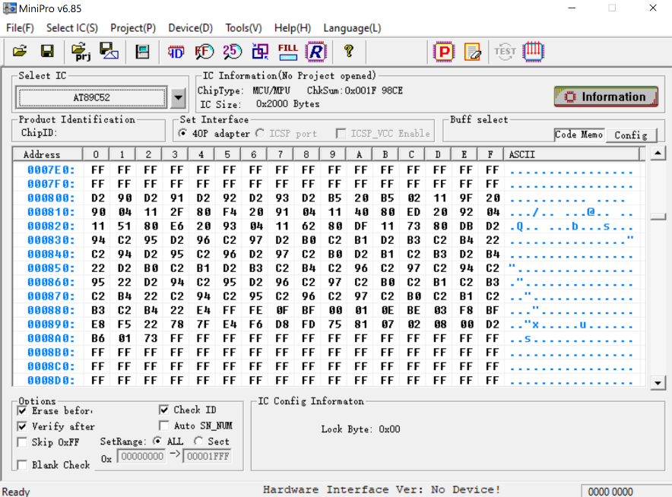

Figure 3.2.2: MiniPro

### Arduino IDE

The Arduino IDE is a free program that allows you to write and upload code to Arduino boards. A code editor, a message area, a text console, a toolbar with standard function buttons, and a series of menus are all included. It connects to the Arduino hardware so that it may upload and communicate with the apps. The IDE application is compatible with Windows, Mac OS X, and Linux operating systems. The programming languages C and C++ are supported.

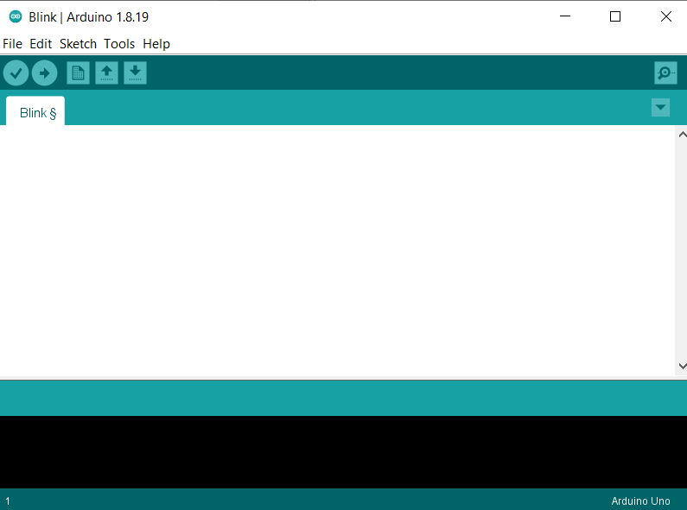

Figure 3-2.3: Arduino IDE

### Proteus

The Proteus Design Set is a software tool package primarily used for electronic design automation. It is used to create schematics and electronic prints for the fabrication of PCB. In Proteus, you can simulate a microcontroller by adding a hex / debug file to the microcontroller section of the schematic. Then, the device is co-simulated, together with any of the analog and digital devices connected to it.

.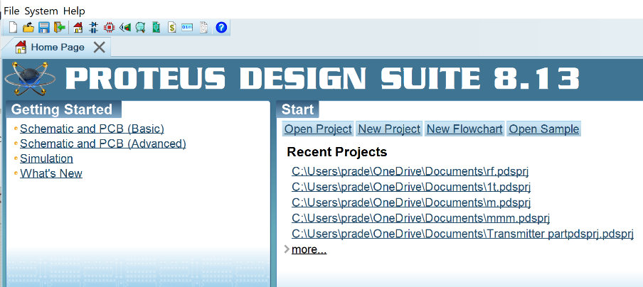

Figure 3.2.4: Proteus

# SYSTEM ARCHITECTURE AND METHODOLOGY

## Block Diagram/ Architecture

The intention of the project is to create a robotic vehicle that can detect metals in its course of action, same as the way of detecting landmines. The robot is controlled via a bluetooth module through an android app(RF signals). It is comprised up of a metal detector circuit connected to the control unit and informs the user behind it of a possible land mine ahead. The required operation is performed with a microcontroller from the 8051 family. The encoder of this robotic vehicle translates 4 bit data , which is then received by bluetooth module, whose output is finally fed to the microcontroller. Our project consists of three parts:

### Metal Detecting Part

LC Circuit

Arduino

Buzzers

Figure 4-1: Block Diagram of Metal Detector

Metal detector circuit comprises of three main parts: the LC Circuit, the Arduino, output LED and the Buzzer.

In an LC circuit, an inductor and a capacitor are linked in series. When similar-frequency material comes close to this circuit, it begins to resonate. The capacitor and inductor are alternately charged in the LC circuit. After the capacitor is fully charged, charge is applied to the inductor. When the charge across the capacitor reaches zero, the inductor begins to charge, and the capacitor draws charge from the inductor in reverse polarity. The inductor charge is then reduced, and the process is repeated.

### Transmitter Part

At the transmitting end, directions are given to the receiver through an android application (available in playstore) named Bluetooth RC control.The directions are provided through four buttons as signal patterns top, bottom, left and right.

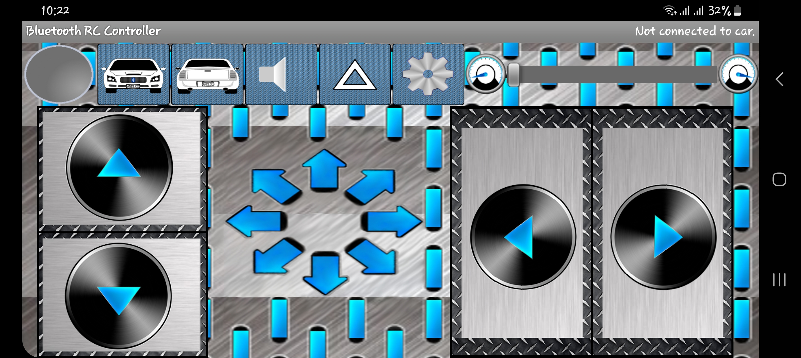

Figure 4-2: Diagram of Transmitter Unit

### Receiver Part

Here, we have make use of four motors connected to the microcontroller at the receiving end. As per the user command or directions, they are utilized to move the vehicle.

8051

Microcontroller

Antenna

Bluetooth module

Power Supply

Voltage regulator

Motor 3

Motor 4

L293D IC

Power Supply

Motor 1

Motor 2

L293D IC

Figure 4-3: Block Diagram of Receiver Unit

The android application is treated and will function as an RF remote to control vehicle within a range of up to 50 meters with the right antenna. Likewise, the receiver decodes the data before passing it to another microcontroller to drive DC motors through a motor driver IC. A metal detector circuit is mounted on the body of robotic vehicle; thus it operates automatically whenever it detects presence of metals. When the robot senses the metal, it alerts with an alarm sound. That indicates any metal is approaching in the course of action.

## **Description of Working Principle**

### **Metal Detection Working:**

When electricity flows through a coil, a magnetic field is created. The change in magnetic field will produce an electric field which opposes the change in magnetic field, according to Faraday's law of induction. Subsequently, a voltage will build across the coil, opposing the current rise. Self-inductance is the term for this effect. The unit of inductance is the Henry. That means when the current changes by 1 ampere per second then a coil having inductance 1 Henry creates a potential difference of 1V. A coil with N windings and a radius R has an inductance of about 5H x N2 x R, where R is measured in meters.

The inductance of a coil is affected by the presence of a metallic object near it. The inductance of a metal can rise or decrease depending on the type of metal. Because a changing magnetic field causes eddy currents in the item, lessening the intensity of the local magnetic field, non-magnetic metals like copper and aluminum reduce inductance. When the element like iron is placed next to a coil, the induced magnetic fields range with the external magnetic field, increasing the coil's inductance.

To detect the presence of metals, we can measure the inductance of a coil. It is feasible to test the inductance of a coil using an Arduino, a capacitor, a diode, and a resistor: by incorporating the coil into a high-pass LR filter and feeding it with a block-wave, brief spikes will be generated at every transition. The inductance of the coil determines the pulse length of these spikes. In reality, tau=L/R is the characteristic time of an LR filter. L 5H x 202 x 0.05 = 100H for a coil with 20 windings and a diameter of 10 cm. The minimum resistance is 200 Ohm to safeguard the Arduino from overcurrent. As a result, we anticipate pulses lasting roughly 0.5 microseconds.

Given the Arduino's 16MHz clock frequency, these are impossible to test directly with great precision. The rising pulse might be used rather to charge a capacitor, which could then be read using ADC. A 0.5 microsecond pulse of 25mA will produce a charge of 12.5nC, which results in 1.25V on a 10nF capacitor. This will be reduced by the voltage drop across the diode. The charge on the capacitor climbs to 2V after a few repetitions of the pulse. This may be read out using analogRead() on the Arduino ADC. By putting the readout pin to 0V for a few microseconds and switching it to output, the capacitor can be swiftly depleted. The entire measurement takes roughly 200 microseconds, with 100 microseconds for the charging of capacitor and it’s resetting and 100 microseconds for the ADC conversion. Repeating the test and averaging the result improves precision by a factor of 16. That’s how a 10-bit ADC gets the precision of a 14-bit ADC.

The aforementioned test is very nonlinear with the coil's inductance, making it unsuitable for measuring the inductance's absolute value. However, for metal detection, we only care about modest relative changes in coil inductance due to the presence of adjacent metals, and this approach is appropriate for that.

It is possible to calibrate the measurement automatically by utilizing software. If it is considered that there is absence of metal next to the coil at most of the time, a divergence from the average indicates that metal has approached the coil. It is possible to differentiate between a sudden rise or fall in inductance by using various colors or tones.

### **Robotic Vehicle Working**

The Robotic Vehicle is administrated by commands sent through a transmitter circuit (android app). The microcontroller is connected to bluetooth module, which are used to receive RF orders from the remote. The microcontroller receives the commands and processes them. After then, the microcontroller processes the user's commands, which include up, down, right, and left direction commands. As a result, it alerts the driver IC, which controls the dc motor to achieve the desired vehicle movement, based on the commands. This is how a robotic vehicle is controlled.

The transmitter circuit and the receiver circuits of this robotic vehicle, are operated using radio frequency. The transmitter circuit coveys the commands required for controlling the robot’s movement. On the other hand, the receiver circuit obtains these instructions via a radio frequency communication link between them, and moves the robot in accordance with the received commands. On the receiver side, a metal detector circuit is bridged to the controller. As a result, if any metal is detected, the buzzer begins to ring.

## 

## Flowcharts/Algorithms

# IMPLEMENTATION DETAILS

In this chapter, implementation of hardware components and software to perform required functions of our system are discussed.

## 5.1 Hardware Implementation

## Arduino Uno for Metal Detection

The Arduino Uno is an ATmega328-based microcontroller board. This board features 14 digital input/output pins (six of which are PWM outputs), six analog inputs, a 16MHz crystal oscillator, a USB connection, a power jack, an ICSP header, and a reset button.

Only two of Arduino are employed to detect metal, one to provide pulses to the LR filter and the other to read out the voltage on the capacitor. Any output pin can be used for pulsing, however one of the analog pins A0-A5 must be used for reading. Two additional pins are utilized for the LED and sound output.

Figure 5-1: Metal Detector using Arduino Schematic

Steps are given below:

1. In series connect the 330 Ohm resistor, the diode, and the 10nF capacitor where negative end of the diode is towards the capacitor.
2. Join A4 to the resistor,
3. Join A5 to the cross-point of capacitor and the cross-point of diode,
4. Connect the capacitor's non-connected terminal to the ground,
5. Join coil’s one end to the cross-point between resistor and diode,
6. Connect the coil's opposite end to the ground,
7. Join one LED's positive terminal to pin D10 and its negative terminal to ground through a 220 Ohm resistor,
8. Attach a buzzer to pin D9 and ground.

### DC Motor Interfacing with 8051 Microcontroller

When we think about operating a robot, the first thing that comes to mind is manipulating DC motors. Connecting a DC motor to a microcontroller is critical in robotic applications. By connecting a DC motor to a microcontroller, we can accomplish a lot with it. For instance, we can administrate the direction and speed of the motor.

In simple terms, a DC motor is a device that transforms electrical energy (from a direct current system) to mechanical energy. At 5V, the microcontroller pin's maximum output current is 15mA. However, most DC motors require more power than a microprocessor can provide, and even the motor's reverse emf (electro motive force) might hurt the microcontroller. As a result, connecting the DC motor to the controller directly isn't a good idea. So, in between the DC motor and the controller, utilize a motor driver circuit.

To drive DC motors, we're using the L293D motor driver IC. With this IC, we could simultaneously run two DC motors. The motor supply for this IC is changeable from 4.5 to 36V and offers a maximum current of 600mA.

Figure 5-2Diagram, schematic

Description automatically generated: DC Motor Interfacing with 8051 Microcontroller

**Working:**

The bluetooth module receives the operator's command, which will be decoded , and the parallel 4-bit data is sent to the first four pins of the 8051 microcontroller's port 1.

**Movement Logic:**

Forward (When port 1.0 is high): All motors rotates in clockwise direction.

IN1 of motor driver 1= 1   
IN2 of motor driver 1= 0

IN3 of motor driver 1= 1   
IN4 of motor driver 1= 0

IN1 of motor driver 2= 1   
IN2 of motor driver 2= 0

IN3 of motor driver 2= 1   
IN4 of motor driver 2= 0

Reverse (When port 1.1 is high): All motors rotates in anticlockwise direction.

IN1 of motor driver 1= 0   
IN2 of motor driver 1= 1

IN3 of motor driver 1= 0   
IN4 of motor driver 1= 1   
   
IN1 of motor driver 2= 0   
IN2 of motor driver 2= 1

IN3 of motor driver 2= 0   
IN4 of motor driver 2= 1

Right (When port 1.2 is high): Left two motors rotates in clockwise direction.

IN1 of motor driver 1= 0   
IN2 of motor driver 1= 0

IN3 of motor driver 1= 1   
IN4 of motor driver 1= 0   
   
IN1 of motor driver 2= 0   
IN2 of motor driver 2= 0

IN3 of motor driver 2= 1   
IN4 of motor driver 2= 0

Left (When port 1.3 is high): Right two motors rotates in clockwise direction.

IN1 of motor driver 1= 0   
IN2 of motor driver 1= 0

 IN3 of motor driver 1= 1   
IN4 of motor driver 1= 0   
   
IN1 of motor driver 2= 0   
IN2 of motor driver 2= 0

IN3 of motor driver 2= 1   
IN4 of motor driver 2= 0 6 RESULTS AND ANALYSIS

## **6 Result And Analysis**

## Metal Detection System

When the metal detector gets close to a metallic object, the LED illuminates in response to the change in coil inductance, and the buzzer sounds an alarm. We see that after constructing this circuit, it detects practically all metallic items. This detector can quickly detect larger metallic items; however small metals are more difficult to detect. In addition, the detection range is narrower than we anticipated. After testing our system on a variety of metallic items of various sizes, we discovered that it has a range of up to 15cm.

Understanding the physics is extremely helpful in interpreting the signals and determining which elements and types are sensitive to the detector. The detector can detect the objects which are at a distance or certain depth to the radius of the coil, as a rule of thumb. It's particularly sensitive to objects where a current can flow in the coil's plane, and the response is proportional to the size of the current loop in that object. Subsequently, a metal disc in the plane of the coil will produce a significantly stronger response than a metal disc that is perpendicular to the coil. The weight of the thing is unimportant. A heavy metal bolt will have a far weaker response than a thin segment of aluminum foil orientated in the plane of a coil.

**Limitation of model**

1. Detects ferromagnetic materials

2. Depends upon the quality of software code.

3. Depens upon inductance of coil.

## Robotic Vehicle

The vehicle is mostly made up of an RF receiver circuit and an 8051 microcontroller, which receives commands from the transmitter and controls the motors appropriately.

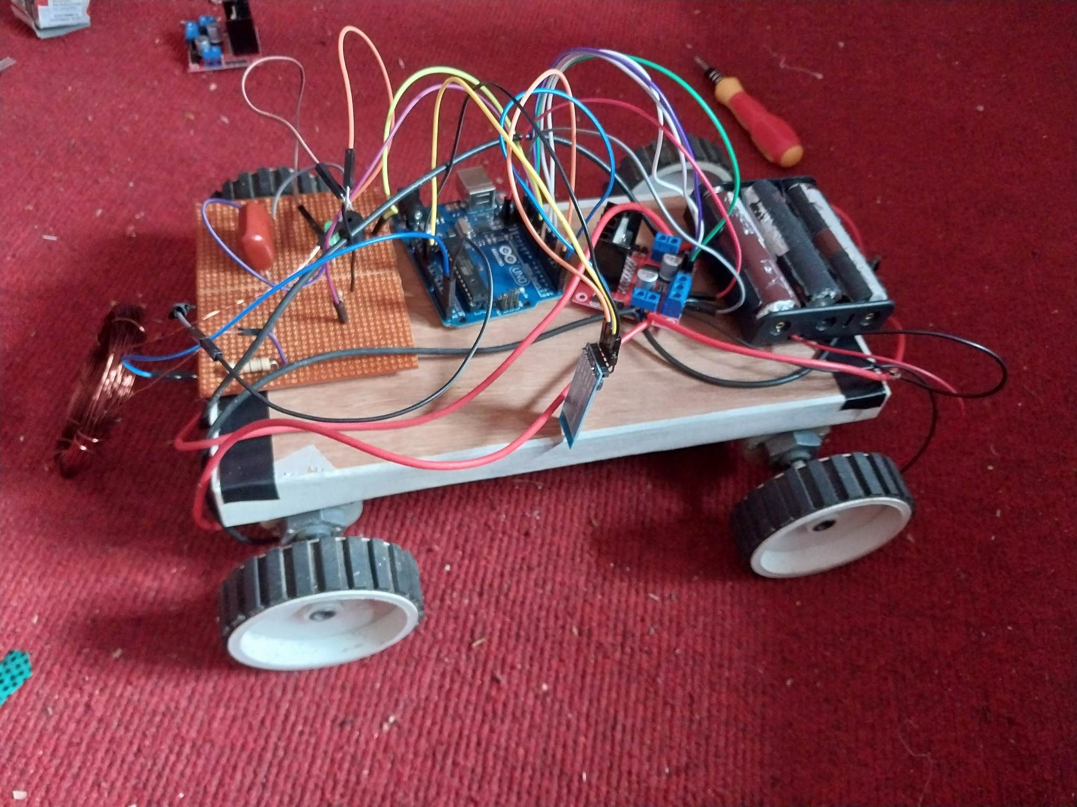

Figure 6-2: Robotic Vehicle

Here we have used a bluetooth module. The range of the RF communication via bluetooth was up to 30 meters. That means we can control our vehicle around that range only. We have used an antenna to expand the range as the range of communication was very small due to noises (produced by dc motors) and some other factors.

The operator can control the vehicle to move in forward, backward, left and right direction by pressing the push buttons of remote (transmitter circuit). The vehicle stops if none of the button is pressed. Finally, we combined all the parts and built a complete RF controlled metal detecting robotic vehicle which alerts and stops after detecting metals.

**7.** **FUTURE ENHANCEMENT**

There is room for improvement in every project and this project is not an exception. There are some rooms for improvement in different functionalities.

Range of our bluetooth module is about 30 meters which will not be enough in real life applications. So, we need to use RF transmitters and receiver with greater range and proper antenna like: RF transmitter and receiver,nRF24, LoRa module, etc. In our robotic vehicle we need to attach a surveillance camera for moving vehicle in regions which are out of our sight.

If the area we are searching is riddled with pop-can tabs or nails, or any variety of junk, this metal detector will not be able to help us filter these annoyances out. And to detect the metal present in the underground, we should use techniques like GPR.

8. **CONCLUSION**

This project shows a metal detecting robot that uses radio frequency communication and is built and operated with an Atmel 89C51 MCU in the embedded system field. The android application transmitter unit's push buttons are used to move the robot in the desired direction. Experiments have been carried out with caution. The results suggest that using the embedded system does result in increased efficacy. This technique has been shown to be extremely beneficial for both security and industrial purposes.

# APPENDICES

## Appendix A: Project Budget

Table 9.1: Project Budget

|  |  |  |
| --- | --- | --- |
| **Hardware Required** | **Unit** | **Costs (Rs)** |
| **Arduino UNO** | 1 | 1600.00 |
| **Bluetooth Module** | 1 | 60000 |
| **Resistors and capacitors** | 3 | 300.00 |
| **Dc Motor** | 4 | 500.00 |
| **Buzzer** | 1 | 50.00 |
| **L293D IC** | 1 | 250.0 |
| **PCB board** | 1 | 50.00 |
| **Coil** | 20 meters | 200.00 |
| **Wheel** | 4 | 200.0 |
| **Battery Pack(3channel)** | 1 | 600.0 |
| **Vehicle Chassis** | 1 | 100.0 |
| **Miscellaneous** |  | 1500.0 |
| **Total** |  | 5,950.00 |

## Appendix B: Project Schedule

Table 9.2: Project Schedule

|  |  |  |  |  |  |  |  |  |  |  |  |  |
| --- | --- | --- | --- | --- | --- | --- | --- | --- | --- | --- | --- | --- |
| Task /Timeline | Week 1 | Week 2 | Week 3 | Week 4 | Week 5 | Week 6 | Week 7 | Week 8 | Week 9 | Week 10 | Week 11 | Week 12 |
| Brain Storming and Topic Discussion |  |  |  |  |  |  |  |  |  |  |  |  |
| Simulation and construction of metal detecting circuit |  |  |  |  |  |  |  |  |  |  |  |  |
| Construction of Transmitter and Receiver circuit |  |  |  |  |  |  |  |  |  |  |  |  |
| Programming 8051 microcontroller |  |  |  |  |  |  |  |  |  |  |  |  |
| PCB fabrication and combining all hardware parts |  |  |  |  |  |  |  |  |  |  |  |  |
| Testing and finalizing the project |  |  |  |  |  |  |  |  |  |  |  |  |
| Documentation |  |  |  |  |  |  |  |  |  |  |  |  |

## Appendix C: Circuit Diagram

Figure 9.3: Metal Detection Circuit

# REFERENCE

|  |  |
| --- | --- |
| [1] | H. S. a. M. Taşdemir, "An Experimental Comparison of Induction Balance Systems," pp. 16-18, 2011. |
| [2] | C. V. Nelson, "Metal Detection and Classification Technologies," *Johns Hopkins APL ,* vol. 25, pp. 62-67, 2004. |
| [3] | G. O. a. C. Moreland, Inside The Metal Detector, Geotech Press, 2015. |
| [4] | M. Stuart, "Microcontroller P.I. Treasure Hunter". |
| [5] | G. S. S. K. G. K. R. M. E. S. A. a. T. N. E. Amareswar, Multipurpose military service robot, 2017 IEEE International Conference of Electronics, Communication, and Aerospace Technology , 2017. |
| [6] | T. B. D. G. a. A. S. A. Lewis, Metal-detector handbook for humanitarian demining, Cat. LB-NA-20837-EN-C, 2003. . |
| [7] | G. Kellermann, "Metal detector, in particular mine detector". USA Patent US Patent 7265551, 08 01 2005. |
| [8] | A. M. L. a. J. K. P. Ripka, "Mine Detection in Magnetic Soils," *Sensor Letters,* vol. 5, pp. 15-18, 2007. |
| [9] | R. Gardiner, "Metal Detector Distinguishing Between Different Metals By Using A Bias Circuit Actuated By The Phase Shifts Caused By The Metals". US Patent US3872380A, 18 03 1975. |
| [10] | J. T. &. E. Grabianowski, "How Airport Security Works," p. 4, 20 June 2001. |
| [11] | "Electronics Hub," [Online]. Available: https://www.electronicshub.org/. |

**Appendix D : System code**

#define capPin A5

#define buz 9

#define pulsePin A4

#define led 10

long sumExpect=0; //running sum of 64 sums

long ignor=0; //number of ignored sums

long diff=0; //difference between sum and avgsum

long pTime=0;

long buzPeriod=0;

int m1a = 5;

int m1b = 6;

int m2a = 11;

int m2b = 12;

char val;

void setup()

{

pinMode(m1a, OUTPUT); // Digital pin 10 set as output Pin

pinMode(m1b, OUTPUT); // Digital pin 11 set as output Pin

pinMode(m2a, OUTPUT); // Digital pin 12 set as output Pin

pinMode(m2b, OUTPUT); // Digital pin 13 set as output Pin

Serial.begin(9600);

pinMode(pulsePin, OUTPUT);

digitalWrite(pulsePin, LOW);

pinMode(capPin, INPUT);

pinMode(buz, OUTPUT);

digitalWrite(buz, LOW);

pinMode(led, OUTPUT);

}

void loop()

{

int minval=1023;

int maxval=0;

long unsigned int sum=0;

for (int i=0; i<256; i++)

{

//reset the capacitor

pinMode(capPin,OUTPUT);

digitalWrite(capPin,LOW);

delayMicroseconds(20);

pinMode(capPin,INPUT);

applyPulses();

//read the charge of capacitor

int val = analogRead(capPin); //takes 13×8=104 microseconds

minval = min(val,minval);

maxval = max(val,maxval);

sum+=val;

long unsigned int cTime=millis();

char buzState=0;

if (cTime<pTime+10)

{

if (diff>0)

buzState=1;

else if(diff<0)

buzState=2;

}

if (cTime>pTime+buzPeriod)

{

if (diff>0)

buzState=1;

else if (diff<0)

buzState=2;

pTime=cTime;

}

if (buzPeriod>300)

buzState=0;

if (buzState==0)

{

digitalWrite(led, LOW);

noTone(buz);

}

else if (buzState==1)

{

tone(buz,2000);

digitalWrite(led, HIGH);

}

else if (buzState==2)

{

tone(buz,500);

digitalWrite(led, HIGH);

}

}

//subtract minimum and maximum value to remove spikes

sum-=minval;

sum-=maxval;

if (sumExpect==0)

sumExpect=sum<<6; //set sumExpect to expected value

long int avgsum=(sumExpect+32)>>6;

diff=sum-avgsum;

if (abs(diff)<avgsum>>10)

{

sumExpect=sumExpect+sum-avgsum;

ignor=0;

}

else

ignor++;

if (ignor>64)

{

sumExpect=sum<<6;

ignor=0;

}

if (diff==0)

buzPeriod=1000000;

else

buzPeriod=avgsum/(2*abs(diff));

}

void applyPulses()

{

for (int i=0;i<3;i++)

{

digitalWrite(pulsePin,HIGH); //take 3.5 uS

delayMicroseconds(3);

digitalWrite(pulsePin,LOW); //take 3.5 uS

delayMicroseconds(3);

}

while (Serial.available() > 0)

{

val = Serial.read();

Serial.println(val);

}

if( val == 'F') // Forward

{

digitalWrite(m1a, HIGH);

digitalWrite(m1b, LOW);

digitalWrite(m2a, HIGH);

digitalWrite(m2b, LOW);

}

else if(val == 'B') // Backward

{

digitalWrite(m1a, LOW);

digitalWrite(m1b, HIGH);

digitalWrite(m2a, LOW);

digitalWrite(m2b, HIGH);

}

else if(val == 'R') //Left

{

digitalWrite(m1a, LOW);

digitalWrite(m1b, LOW);

digitalWrite(m2a, HIGH);

digitalWrite(m2b, LOW);

}

else if(val == 'L') //Right

{

digitalWrite(m1a, HIGH);

digitalWrite(m1b, LOW);

digitalWrite(m2a, LOW);

digitalWrite(m2b, LOW);

}

else if(val == 'S') //Stop

{

digitalWrite(m1a, LOW);

digitalWrite(m1b, LOW);

digitalWrite(m2a, LOW);

digitalWrite(m2b, LOW);

}

else if(val == 'G') //Forward Right

{

digitalWrite(m1a, HIGH);

digitalWrite(m1b, LOW);

digitalWrite(m2a, LOW);

digitalWrite(m2b, LOW);

}

else if(val == 'H') //Backward Right

{

digitalWrite(m1a, LOW);

digitalWrite(m1b, HIGH);

digitalWrite(m2a, LOW);

digitalWrite(m2b, LOW);

}

else if(val == 'I') //Forward Left

{

digitalWrite(m1a, LOW);

digitalWrite(m1b, LOW);

digitalWrite(m2a, HIGH);

digitalWrite(m2b, LOW);

}

else if(val == 'J') //Backward Left

{

digitalWrite(m1a, LOW);

digitalWrite(m1b, LOW);

digitalWrite(m2a, LOW);

digitalWrite(m2b, HIGH);

}

}

**Appendix E : Data sheet of L298N (Motor Driver )**

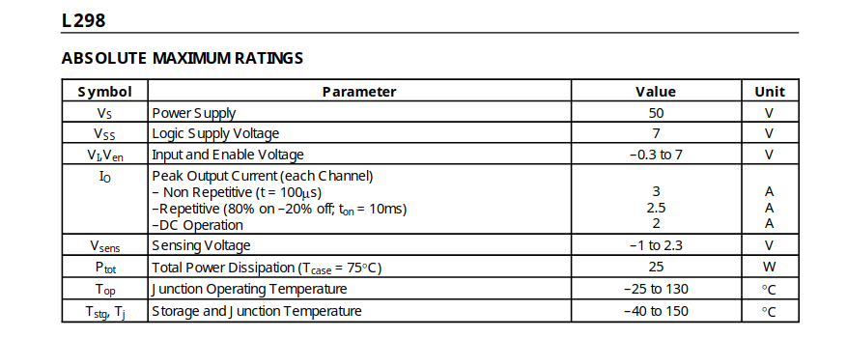

**Appendix F : Data Sheet of HC-06 (Bluetooth Module)**

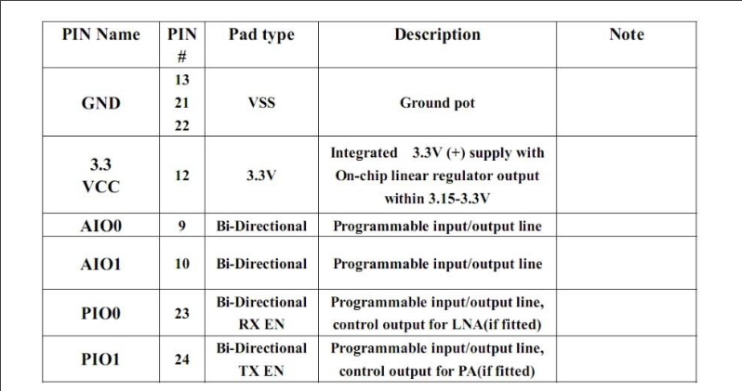

**Appendix D : Data Sheet of Arduino**

